**Child Mortality**

Data that was given can be used to analysis the mortality trends over the period of 1990 to 2015.Infants Mortality rate is number of deaths per thousand lives in the children in between the age of 0-1years .The graphs will help you to understand these trends as follows:

1st graphs shows the infant mortality rate in the period of 1990 for every 10th country in ascending order.

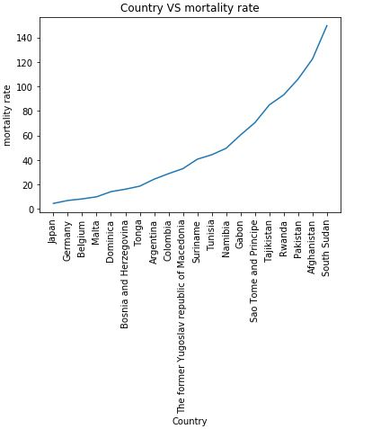

The inferences that can be seen from this graph are as follows

* Japan has the least infant mortality rate in the year 1990
* South Sudan has the highest.

2nd graph is a bar graph that show the infant mortality rate of individual countries

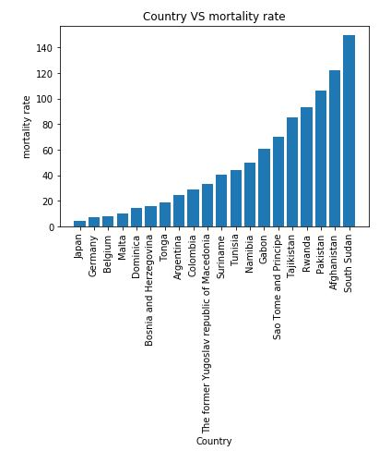

We can infer the following thing:

* Japan has the lowest rate i.e. near to 2.5 in 1990.
* South Sudan has highest that is nearly equal to 145.

3rd graph is a bar graph that shows the infant mortality rate of individual countries in ascending order in 2015

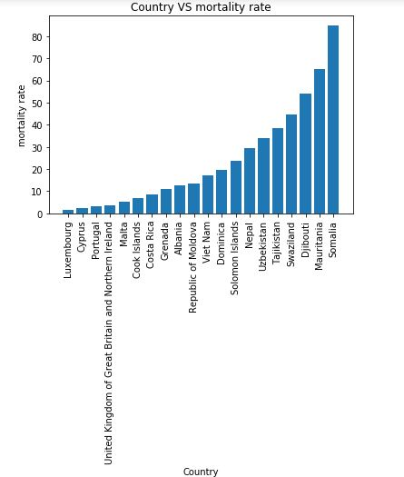

The inferences from are graph are:

* The rate for the all countries has decreased by large margins as the highest seen in 1990 was 145 but now the highest has dropped to 85 around this show that the medical facilities has improved over the years.
* The rate in Luxembourg in the lowest that is around 1.5. That is decreased from 7.3 that show a good amount of decrease in the country.

4th graph in the comparison between three different countries namely Japan, Fiji and Czech Republic.

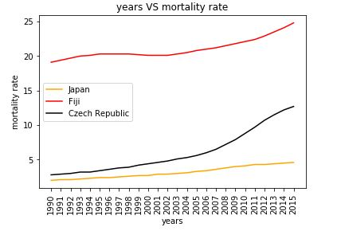

The inference can be from the above graph can be:

* All the three countries has shown increase in infant mortality rate it can indicate that all the countries has an increase in the number of child births and decrease in the medical facilities
* The trends in Fiji shows that the rate decreased for small time it can be due to some policies of government but as this graph than increased this can also tell that it was as anomaly
* There is a sudden increase in the infant mortality rate in Czech Republic this is an indication of a war, drought or some natural calamity.

The 5th graph is the reduction rate for the infancy morality rate in the above three countries.

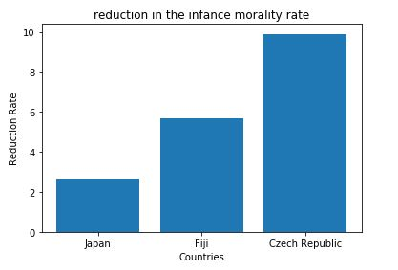

We can infer the following things:

* Czech Republic has the most difference between the infant mortality rates this show that there is some problem with its health management system of the countries or the eating habits of the people.
* The infant mortality rate of japan has increased the least

Code for the program

import matplotlib.pyplot as pt

import pandas as pd

import numpy as np

import operator

def line_graph_countries():

colnames=['Country','Year','Infant_mortality_rate','Neonatal_mortality_rate','Under-five_mortality_rate']

data=pd.read_csv("WHOSIS_MDG_000003.csv",names=colnames)#reading the data from file

country=data.Country.tolist()

year=data.Year.tolist()

IM=data.Infant_mortality_rate.tolist()

IM_bar=[]

country_bar=[]

# extraing the info for specific year

for x in range(len(year)):

if year[x] == '1990':

temp=IM[x].split("[")

IM_bar.append(float(temp[0]))

country_bar.append(country[x])

dictionary = dict(zip(country_bar,IM_bar))

sorted_x = sorted(dictionary.items(), key=operator.itemgetter(1))

country=[]

IM=[]

for x in range(0,len(sorted_x),10):

country.append(sorted_x[x][0])

IM.append(sorted_x[x][1])

pt.plot(country,IM)

pt.xticks(country, country, rotation='vertical')

pt.xlabel("Country")

pt.ylabel("mortality rate")

pt.title("Country VS mortality rate")

pt.show()

def bar_graph_countries(inyear):

colnames=['Country','Year','Infant_mortality_rate','Neonatal_mortality_rate','Under-five_mortality_rate']

data=pd.read_csv("WHOSIS_MDG_000003.csv",names=colnames)#reading the data from file

country=data.Country.tolist()

year=data.Year.tolist()

IM=data.Infant_mortality_rate.tolist()

# varible name with _bar is the lists that are used in the graph plotting

IM_bar=[]

country_bar=[]

# extrating the info for year 1990

for x in range(len(year)):

if year[x] == inyear:

temp=IM[x].split("[")

IM_bar.append(float(temp[0]))

country_bar.append(country[x])

dictionary = dict(zip(country_bar,IM_bar))

# sorting the information

sorted_x = sorted(dictionary.items(), key=operator.itemgetter(1))

country=[]

IM=[]

for x in range(0,len(sorted_x),10):

country.append(sorted_x[x][0])

IM.append(sorted_x[x][1])

pt.bar(country,IM)

pt.xticks(country, country, rotation='vertical')

pt.xlabel("Country")

pt.ylabel("mortality rate")

pt.title("Country VS mortality rate")

pt.show()

def compare_plot():

colnames=['Country','Year','Infant_mortality_rate','Neonatal_mortality_rate','Under-five_mortality_rate']

data=pd.read_csv("WHOSIS_MDG_000003.csv",names=colnames)#reading the data from file

country=data.Country.tolist()

year=data.Year.tolist()

IM=data.Infant_mortality_rate.tolist()

IM_bar1=[]

IM_bar2=[]

IM_bar3=[]

year_bar1=[]

year_bar2=[]

year_bar3=[]

for x in range(len(country)):

if country[x] == 'Japan':

temp=IM[x].split("[")

IM_bar1.append(float(temp[0]))

year_bar1.append(year[x])

elif country[x] == "Fiji":

temp=IM[x].split("[")

IM_bar2.append(float(temp[0]))

year_bar2.append(year[x])

elif country[x] == "Czech Republic":

temp=IM[x].split("[")

IM_bar3.append(float(temp[0]))

year_bar3.append(year[x])

pt.plot(year_bar1[::-1],IM_bar1,color="orange",label="Japan")

pt.plot(year_bar2[::-1],IM_bar2,color="red",label="Fiji")

pt.plot(year_bar3[::-1],IM_bar3,color="black",label="Czech Republic")

pt.legend()

pt.xticks(year_bar1,year_bar1, rotation='vertical')

pt.xlabel("years")

pt.ylabel("mortality rate")

pt.title("years VS mortality rate")

pt.show()

def reductoin_in_MR():

colnames=['Country','Year','Infant_mortality_rate','Neonatal_mortality_rate','Under-five_mortality_rate']

data=pd.read_csv("WHOSIS_MDG_000003.csv",names=colnames)#reading the data from file

country=data.Country.tolist()

year=data.Year.tolist()

IM=data.Infant_mortality_rate.tolist()

for x in range(len(country)):

if country[x] == 'Japan':

if year[x]=='1990':

temp=IM[x].split("[")

initial1=float(temp[0])

elif year[x]=='2015':

temp=IM[x].split("[")

final1=float(temp[0])

elif country[x] == "Fiji":

if year[x]=='1990':

temp=IM[x].split("[")

initial2=float(temp[0])

elif year[x]=='2015':

temp=IM[x].split("[")

final2=float(temp[0])

elif country[x] == "Czech Republic":

if year[x]=='1990':

temp=IM[x].split("[")

initial3=float(temp[0])

elif year[x]=='2015':

temp=IM[x].split("[")

final3=float(temp[0])

reduction_rate=[initial1-final1,initial2-final2,initial3-final3]

countries=['Japan','Fiji','Czech Republic']

pt.bar(countries,reduction_rate)

pt.xlabel("Countries")

pt.ylabel("Reduction Rate")

pt.show()

line_graph_countries()

bar_graph_countries('1990')

bar_graph_countries('2015')

compare_plot()

reductoin_in_MR()